**Kratin Task**

# Project Name : Automated alarm system for Overloaded Diaper and pads.

# Technology Used : Internet of Things

# Program for Arduino:

# const int analogInPin = A0;

# int sensorValue = 0;

# void setup() {

# // declare pin to be an output:

# pinMode(15, OUTPUT);

# Serial.begin(9600);

# }

# // the loop routine runs over and over again forever:

# void loop() {

# sensorValue = analogRead(analogInPin);

# Serial.print("sensor = ");

# Serial.print(sensorValue);

# Serial.print("\n");

# delay(2);

# if (sensorValue >= 100 && sensorValue <= 600) {

# digitalWrite(15, HIGH);

# delay(100);

# } else {

# digitalWrite(15, LOW);

# delay(100);

# }

# }

**Setup :**

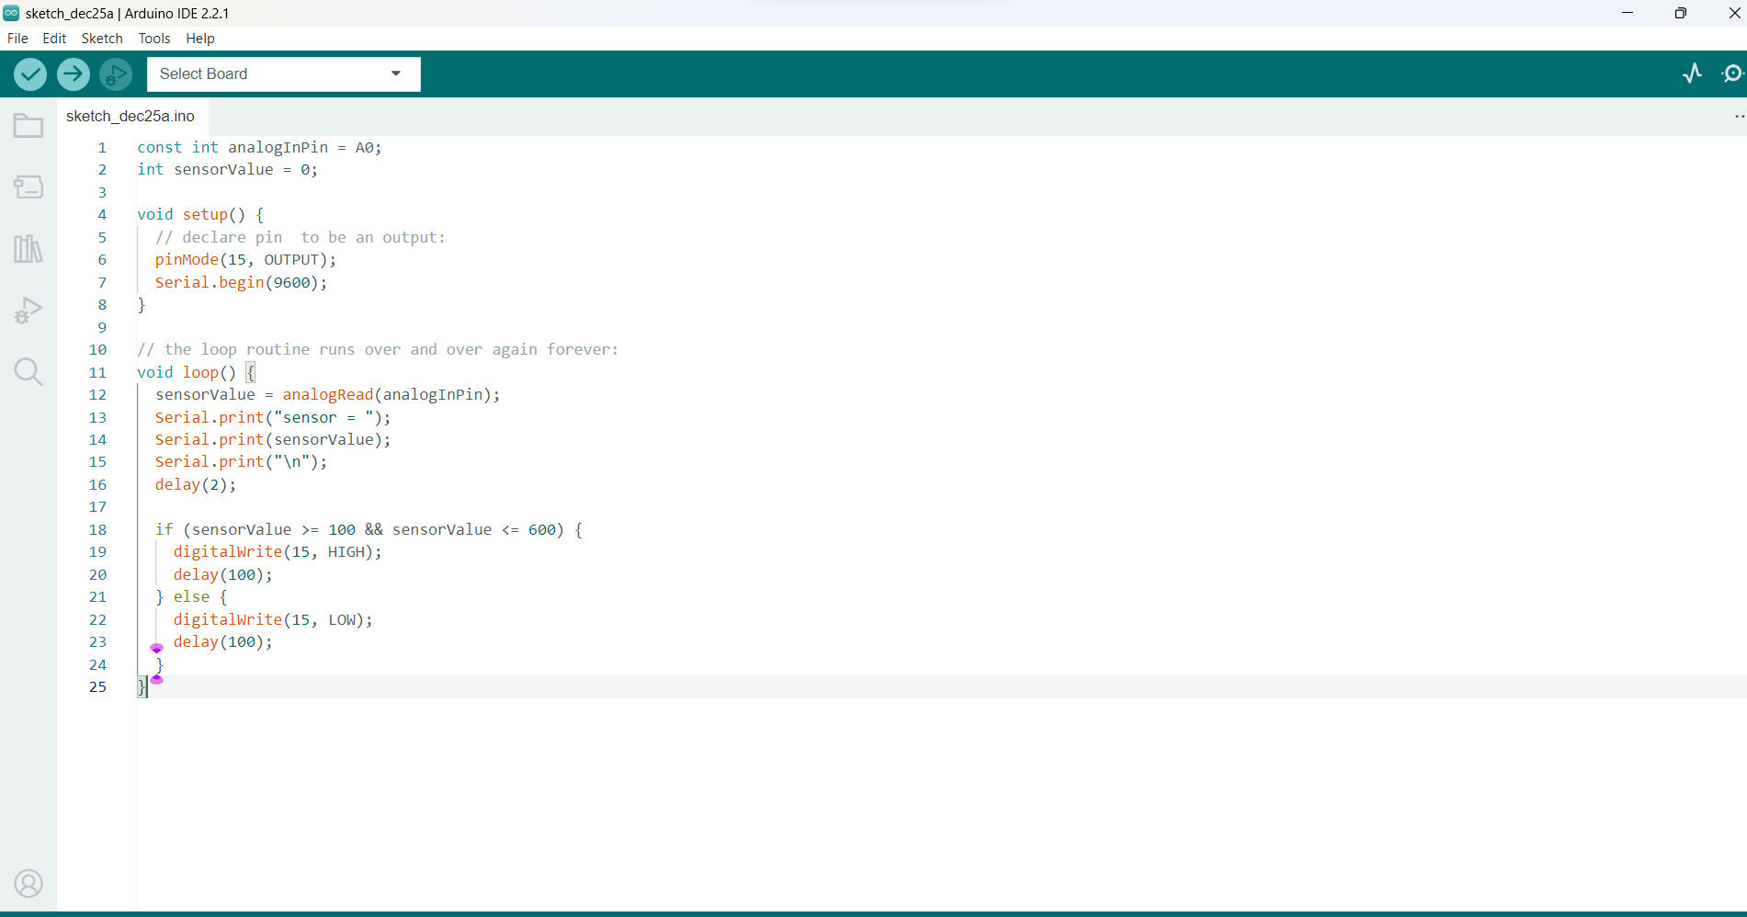

**Circuit :**

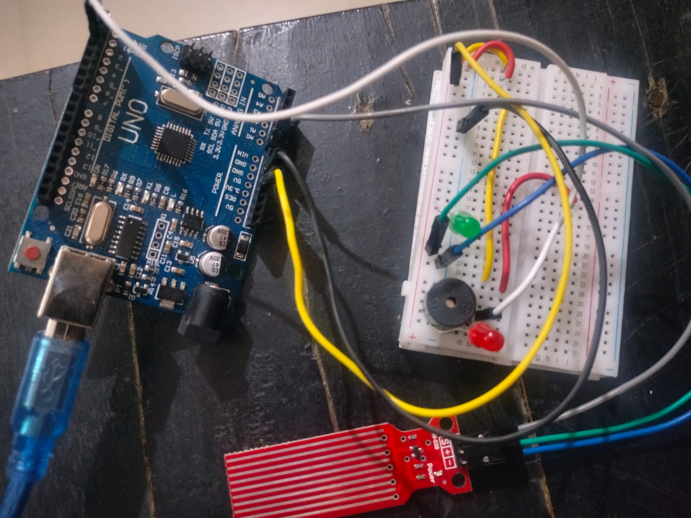

**In this above Circuit , when Sensor detect the moisture then it will generate alarm using Buzzer.**

**If we inserted this circuit in the diaper/pads of old aged patients who are bedridden then this will definitely help them by maintaining health proper condition.**

**Circuit Detecting Moisture and Giving Alarm:**

